School Progress Report
Kay Lawrenson
St Marys Aided School, Overton
School: School Contact:
Visit
18.09.2018
NB
Officer: Date: Type of support:

Food & Fitness | Emotional Health | Personal Development | Hygiene | Safety | Environment | Substance Use and Misuse | NQA
2010 | 2013 | 2013 | 2012 | 2012 | 2011 | 2014 | 2015
Firstly congratulations on achieving the Third Annual Review of the Welsh Network of Healthy School Schemes National Quality Award. We are pleased to confirm that St Marys Aided Primary, Overton On Dee has demonstrated sustainability of all the criteria of the National Quality Award. These criteria are set out against 7 health topics:

- Food and fitness (nutrition and physical activity)
- Mental and emotional health and wellbeing, including staff wellbeing
- Personal development and relationships, including sex and relationships education
- Substance use and misuse, including alcohol, smoking, and drugs (legal, illegal, and prescription).
- Environment, including eco-initiatives and improving the school and wider Environment
- Safety, including a variety of topics such as child protection, sun safety, internet safety, and first aid
- Hygiene including across school and non-school settings

The criteria are supported by a number of underlying principles, namely:
- The importance of pupil participation in core areas of school life which directly affect the health and wellbeing of children and young people e.g. teaching and learning, environment, pastoral care.
- The importance of the understanding and commitment to action of the whole school community.

Food & Fitness

St Mary’s Overton has always believed in Strong Pupil Voice. Last year the Student Council piloted a Fruit Tuck Shop and as a result of this they would like to start up a Fruit Tuck shop in the school for the KS2 pupils in order to offer a healthy alternative to some foods that are brought in from home. The school gardening area has been developed with the support of parents and has produced so much fruit and veg that the children have been eating the apples for snack in school and an after school vegetable sale took place for parents to buy the produce. The school raised a fantastic £35 of sales for their vegetables.

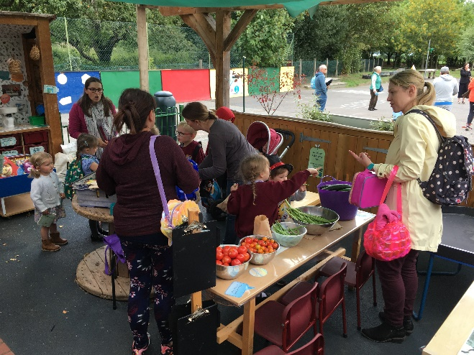
Fruit and Veg sale

The school continues to offer a wide selection of after school activities which includes Football, Netball, Gymnastics, Cricket, Cross Country, Swimming, Athletics as well as getting involved in county tournaments. The school has taken part in Sports Relief, indoor bowling, tennis and golf this year, aswell as welcoming into school Wrexham Football Club, Taekwondo sessions and Diddy Dance for the Foundation Phase pupils.
4 Members of staff have received Play worker Training this year to support work with the Green Time Project that the Play Development Team have supported the school with. One member of staff is currently training for a half marathon in aid of Cervical Cancer (Target Ovarian Cancer).
Some Year 5 pupils have been trained as playmakers where they do a rota of games to be played on the yard during break and lunch. The children enjoy being playmakers and get to wear a hi-vis jacket so they can be identified by other pupils during break time.
The school celebrated the Royal Wedding in May and took part in cooking some of the food that you would have on a Royal Wedding Day.
The children in KS2 did topic work on WW2 and they looked at the foods that would have been rationed during that time. Children in Foundation Phase looked at the Eatwell Plate and how a balanced diet looks.
Mental and emotional health and wellbeing, including staff wellbeing

Mental and emotional health and wellbeing is at the heart of the ethos, values, culture and everyday life of the school, for both pupils and members of staff. There are a range of initiatives in place in order to promote and encourage emotional health and wellbeing, which include SAP, Circle Time, Friends Programme, Growth Mindset and Celebration Assemblies that take place every Friday. The school is also embedding Pivotal Behaviour Management into the school which is working well.
Yr 6 pupils complete a transition form for their local feeder secondary which is discussed with them by the Head of year 7 and they fill in their interests and friendship groups. They are visited by 4 pupils from current year 7 (pupils that left last year from St Marys) and lots of their initial fears are answered.
The school does their own work in class about their hopes and fears which are the basis of our leaving assembly at St. Mary's Church in July. Year 5 also make individual prayers and light candles for their friends in year 6 who are leaving
The school continues to fundraise, with staff and pupils taking part in MacMillan and Jeans for Genes which is fundraising for vulnerable children affected by a genetic disorder and Sport Relief. Last year the school was doing a lot of fundraising for a little girl in school called Daisy who had cancer. Sadly Daisy passed away and to support the pupils the church created a tree in church where children could write messages to daisy and express their feelings. A wooden bench was created by a sculpture called Edward Park and paid for by a couple of parents at school in memory of Daisy and is now placed in a reflection area in the school grounds for the children to visit.
Staff have all received Braveheart Training on supporting vulnerable children who have lived, or are living with attachment issues or trauma. Pupils in school have received workshops from the Spectrum project which looks at raising awareness of domestic abuse and discusses healthy relationships with the pupils. The Foundation Phase pupils have also participated in the Don’t Touch tell Session.
A Values Award has been started in school which is voted for by the pupils and is based on the christen values of the school. One wooden star for a Foundation Phase pupil and a wooden star for a KS2 pupil is awarded weekly.
The school is also part of the Shirley Clarke visible learning programme which looks at empowering children to become confident learners who know how to learn.

Personal Development and Relationships

There is a graduated, age related scheme of work in place for Sex and Relationships Education. These include naming the body parts and appropriate and inappropriate touching. The Growing Up resources and SENSE CD-Rom are used to deliver the sessions to the pupils in school and in year 5 and 6 the areas of Hygiene, Conception and Birth are discussed.
The school is also keen to ensure all staff have received training and a healthy schools officer is booked in to deliver whole staff training on the resources to ensure the key messages and consistency are continuing to be delivered to the pupils in school.

Substance Misuse

The policy on smoking is fully compliant with the requirements of the award and No Smoking Signs are on display around the school. The Community Police Officer visits the school regularly and delivers the sessions relating to the safety of substances within the lessons matrix.
Don’t Touch Tell have also visited the school and delivered an assembly for the pupils.

Environment

This continues to be a particular strength in the school and pupils participate in the efforts to improve the school and the wider environment. The school continue to develop their eco club and continue to work towards their green flag. Forest schools is timetabled in for all classes in the school and the area for forest schools has been extended for the KS2 pupils so they are able to use it permanently. It is also used as a transition area for the playgroup children to attend to support the transition into the nursery class in school. The school is still collecting cans for the British Ironworks Centre in Oswestry who are running a project to encourage schools to collect tin cans for them to be able to build a model of the Queen. The school has taken part in ‘The GreenTime Project’ which is through the Play Development Team looking at Loose parts play. 4 members of staff received playworker training to support the pupils in school doing the project.
Some past parents of the school were involved in a charity which collected school uniforms and bras for pupils and young women in Uganda. The school were happy to help support the charity called Elizabeth House and collected a good amount of uniforms to be sent back to Uganda. Providing a bra to young women in Uganda shows a sign of status in society and provide the young women with a bit more confidence and self-esteem.
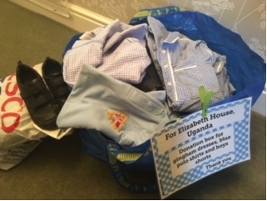
Uniform collection

4 members of staff have been trained in outdoor learning.
A parent of the school also made a book case with a glass door that is located at the outside entrance of the school near reception where members of the community can do book swaps. A great idea that has proved very successful.
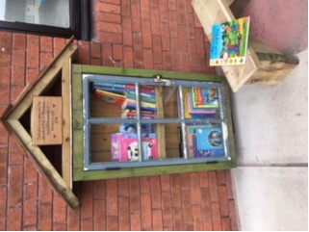
Recycled Book Case

Safety

The school provides a range of activities to the pupils that involve other organisations providing support and includes; the Police Liaison scheme, child protection training, first aid training, Don’t touch Tell, swimming lessons and a transition programme for pupils in year 6 with their feeder secondary.
The school has pupils that are digital leaders and took part in Safer Internet day, and e-safety lessons were delivered to the pupils via the Hwb platform.

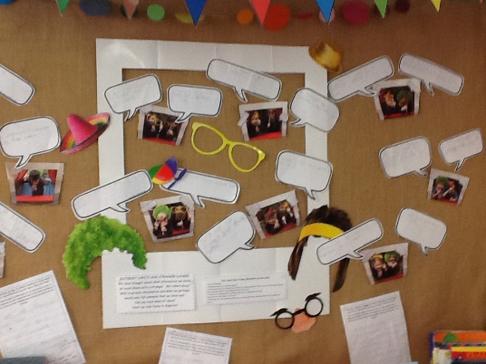
Keeping ourselves safe online display
The forest school provides a challenge for risk assessment that is well addressed by the school.
Cooking club after school provides messages of safety when handling equipment and staff, parents and pupils have received deliberator training.

Hygiene

The hygiene policy conforms to current regulations and all the minimum standards are adhered to. Aspects of hygiene are linked very well to the curriculum. Displays such as the ‘Wash our Hands’ succeed in reinforcing the healthy schools message in respect of hygiene. The growing up talks in year 5 and 6 include discussion on personal hygiene and the popular cooking club discusses food hygiene as good practice.

Areas for further consideration

Maintain current practice and school will consider looking at the following:
- Whole staff training on Sex and Relationships Education 2019 – Booked for 13th Feb 2019
- Contacting a school that already runs a successful fruit tuck shop to gain advice on how to run the one in school. Barkers Lane CP & Brynteg CP
- NB to send the school traffic lights behaviour charts from the Parents Protect Programme.
https://www.parentsprotect.co.uk/files/traffic_light_helping_you_understand_the_sexual_development_of_children_under_5.pdf
https://www.parentsprotect.co.uk/files/traffic_light_helping_you_understand_the_sexual_development_of_children_5-11.pdf

